Info package for the project: MAKE PEACE NOT WAR

Holland: 30th of april until 7th of may 2016
Participants: 11 per country, including 1 leader
Age: 18 – 25 (approximately)

Electricity:

The power supply in netherlands is 240 volts a.c. 50Hz.
The sockets are usually 16 amp.

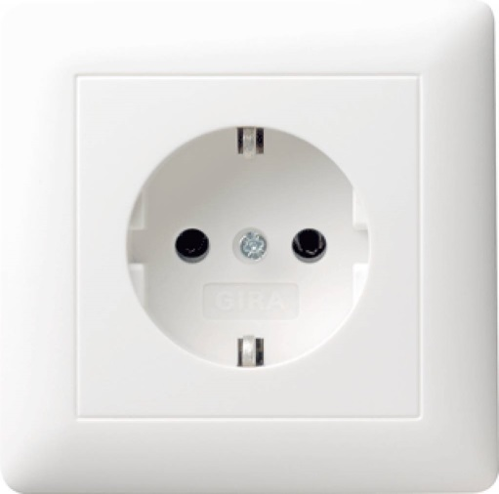

More than one low current rating appliance may be operated from the same supply point, by using an adaptor. For example radios, electric clocks ect.
This is not recommended voor high current appliances / divices. Like electric heaters, hairdryers, irons ect.

Wheather:

 It will be modorate to cool. The hottest will be about 20 degrees and the coolest about 5 degrees. At nights is can be cold so we advice to bring a warm jacket.
There can be rain so pleace dress accordingly.

Health insurance:

Remember health insurance is your responsibility so make sure you have E111 or private insurance.
Also you are required to have travel insurance. Your sending organisation should have informed you of this so please ask them about it.

Medication:

If you take any medication please remember tob ring it withe you, we have pharmacies here but if you need prescription medication you cannot buy them over the counter without a prescription.

!! if participants have any allergies especially to foods this needs to be expressed as soon as possible, give us some time to work on your special needs please. Changes to the menu will not be possible once the project starts. !!



Detailed information about the accommodation will be given to you later on. We are working on that issue at this moment! But don’t worry, it will all be fine!

You can start checking out cheap flight tickets form now on.

Remember that there are maximum budgets for flight tickets and only 70% will be covered by the program. Within Holland there will be travel costs too, approximately 40 euros per person.

For Italy the maximum covered budget is 130 euros per person (170 -40)
For Cyprus the maximum covered budget is 230 euros per person (270 -40)

If you have any questions about the information in this info pack, please don’t hesitate to contact us!
We look forward to meeting you all in Holland very much!

Friendly greetings,
On behalf of the whole group Remon, Patti, Erik, Dominique, Rick, Mellisa, Marc, Patricia, Mark, Stefanie, Kennie, Esther, Kevin, Diana, Arjan, Narell, Randy, Jantina and Marjolein

Wietske Visser, youth worker

